MODULE I | MCA-301 COMPUTER GRAPHICS | ADMN 2011-‘14

1.4 LINE DRAWING ALGORITHMS

Several line drawing algorithms are developed. Their basic objective is to enable visually satisfactory images in least possible time. This is achieved by reducing the calculations to a minimum. This is by using integer arithmetic rather than floating point arithmetic. This way of minimizing even a single arithmetic operation is important. This is because every drawing or image generated will have a large number of line segments in it and every line segment will have many pixels. So saving of one computation per pixel will save number of computations in generating an object. This in turn minimizes the time required to generate the whole image on the screen.

1.4.1DDA ALGORITHM (DIGITAL DIFFERENTIAL ANALYZER)

Suppose we are given the 2 end points of a line. (xstart, ystart) and (xend,

yend).

(xend, yend)
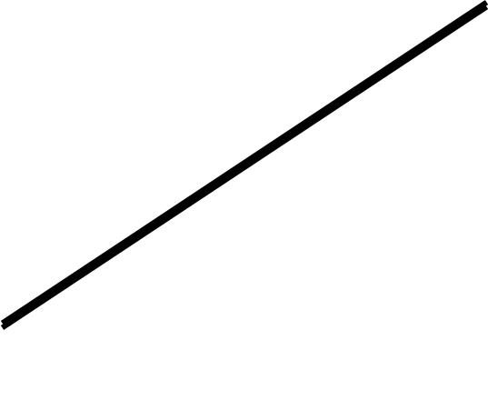

(xstart, ystart)

(Fig: 1.34 - Line path between end point positions (xend, yend) and (xstart, ystart))

We know that the general equation of a line is y = mx + c. Where m is the slope of the line and c is the y- intercept. (x, y) is any point on the line.

We also know that the slope of the above line can be expressed as:-
yend – ystart
m = ----------------
xend - xstart

Suppose we are given 2 points on the line as (xi, yi) and (xi+1, yi+1)then also slope,
yi+1 - yi
m = -----------
xi+1 - xi
We can say that

yi+1 - yi = dy

and

xi+1 – xi = dx

Then

Dept. of Computer Science And Applications, SJCET, Palai 26

MODULE I | MCA-301 COMPUTER GRAPHICS | ADMN 2011-‘14

dy
m = ----
dx

That is dy = m dx

Thus for any given x interval dx along the line, we can compute the corresponding y interval dy.

Now suppose

xi+1 – xi = 1 or dx = 1

It means

xi+1 = xi + 1

Then

dy = m which means

yi+1 – yi= m

That is
yi+1 = yi + m | 1
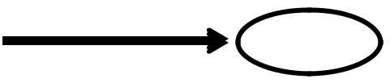

Thus a unit change in x changes y by m, which is constant for a line.

We know that if

xi+1 = xi + 1, then

yi+1 = yi +m

Initializing (xi, yi) with (xstart ,ystart), the line can be generated by incrementing the previous x values and solving the corresponding y value at each step, till xend is reached.at each step, we make incremental calculations based on the previous step. This is what is defined as incremental algorithm and often referred to as the Digital Differential Analyzer (DDA) algorithm.

We know

dy

m = ----

dx

If |m| <= 1 which means |dy| <= |dx|, we sample the line at unit x intervals. But if |m| >1, in this a unit step in x creates a step in y that is greater than 1, which is not desirable. In this case we reverse the roles of x and y by sampling at unit y intervals as,

dy = yi+1 – yi = 1

implies yi+1 = yi + 1

dy
m = ----

dx

implies 1

xi+1 – xi = ---

m

implies

Dept. of Computer Science And Applications, SJCET, Palai 27

MODULE I | MCA-301 COMPUTER GRAPHICS | ADMN 2011-‘14
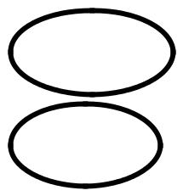

1
xi+1 = xi +--- | 2
m
yi+1 = yi + m | 3
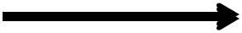
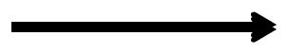

These equations are based on the assumption that xstart<xend and ystart<yend. That is slope m is positive. But if it is not the case, we have to apply negative increment for the other possible cases.

The algorithm for rasterizing a line according to DDA logic is presented below.

DDA ALGORITHM

- START

- Get the values of the starting and ending co-ordinates i.e. ,(xa,ya) and (xb,yb).

- Find the value of slope m

m=dy/dx=((yb-ya)/(xb-xa))

- If ImI ≤ 1 then ∆x=1,∆y=m∆x
x_{k+1}=x_{k}+1,y_{k+1}=y_{k}+m

- If ImI ≥ 1 then ∆y=1,∆x=∆y/m
x_{k+1}=x_{k}+1/m,y_{k+1}=y_{k}+1

- STOP

1.4.2 BRESENHAM'S LINE ALGORITHM

An accurate and efficient raster line-generating algorithm, developed by Bresenham, scans converts lines using only incremental integer calculations that can be adapted to display circles and other curves. Figures 1.35 and 1.36 illustrate sections of a display screen where straight line segments are to be drawn. The vertical axes show-scan-line positions, and the horizontal axes identify pixel columns. Sampling at unit x intervals in these examples, we need to decide which of two possible pixel positions is closer to the line path at each sample step. Starting from the left endpoint shown in Fig. 1.35, we need to determine at the next sample position whether to plot the pixel at position (11, 11) or the one at (11, 12). Similarly, Fig. 1.36 shows-a negative slope-line path starting from the left endpoint at pixel position (50, 50). In this one, do we select the next pixel position as (51,50) or as (51,49)? These questions are answered with Bresenham's line algorithm bytesting the sign of an integer parameter, whose value is proportional to the difference between the separations of the two pixel positions from the actual line path.

To illustrate Bresenharn's approach, we-first consider the scan-conversion process for lines with positive slope less than 1. Pixel positions along a line path are then determined by sampling at unit x intervals. Starting from the left endpoint (x₀, y₀) of a given line, we step to each successive column (x position) and plot the pixel

Dept. of Computer Science And Applications, SJCET, Palai 28

MODULE I | MCA-301 COMPUTER GRAPHICS | ADMN 2011-‘14

whose scan-line y value is closest to the line path. Assuming we have determined that the pixel at (x_{k}, y_{k}) is to be displayed, we next need to decide which pixel to plot in column x_{k+1},.Our choices are the pixels at positions (X_{k}+l, y_{k}) and (x_{k+l}, y_{k}+l).
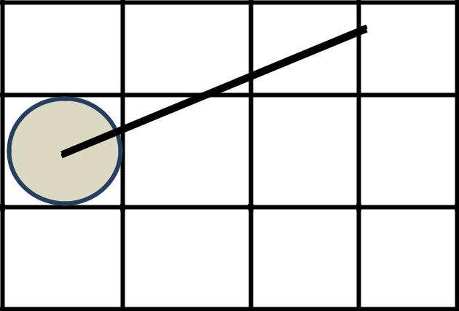

12

11

10

10 11 12

(Fig: 1.35 - Section of a display screen where a straight line segment is to be plotted,

starting from the pixel at column 10 on scan line 11)

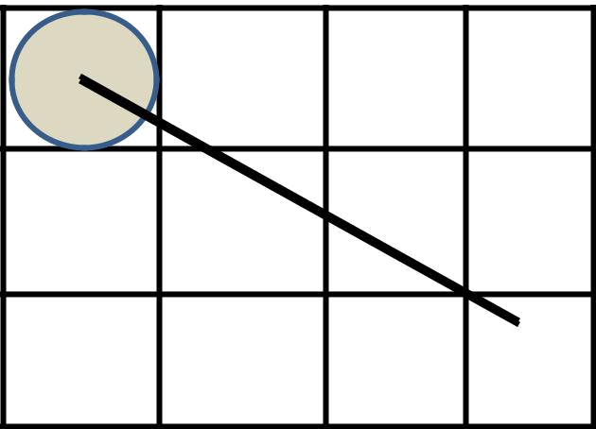

50

49

48

50 51 52 53

(Fig: 1.36 - Section of a display screen where a negative slope line segment is to be

plotted, starting from the pixel at column 50 on scan line 50)

At sampling position x_{k}+l, we label vertical pixel separations from the mathematical line path as d₁and d2 (Fig. 1.37). Theycoordinates on the mathematical line at pixel column position x_{k}+l is calculated as
y=m(x_{k}+1)+b

Then
d₁=y-y_{k}
=m(x_{k}+1)+b-y_{k}

and

Dept. of Computer Science And Applications, SJCET, Palai 29

MODULE I | MCA-301 COMPUTER GRAPHICS | ADMN 2011-‘14

d2=(y_{k}+1)-y
=y_{k}+1-m(x_{k}+1)-b

The difference between these two separations is
d1-d2=2m(x_{k}+1)-2y_{k}+2b-1  4
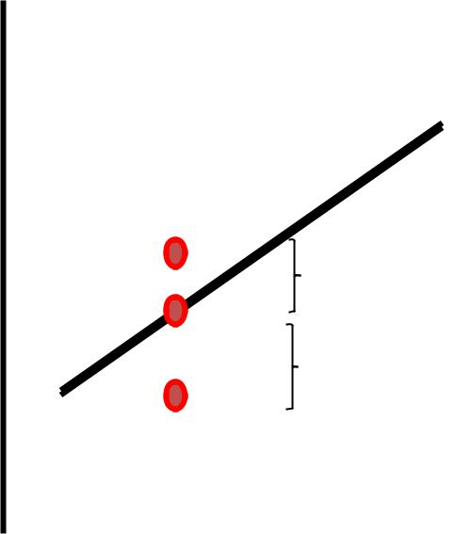

yk+1 | d₂
y | d₂
yk | d₁

x_{k}+1

(Fig: 1.37 - Distance between pixel positions and the line y coordinates at sampling position x_{k}+1)

A decision parameter pkfor the kth step in the line algorithm can be obtained by rearranging Eq. 4 so that it involves only integer calculations. We accomplish this by substituting m = ∆y/∆x, where ∆y and ∆x are the vertical and horizontal separations of the endpoint positions, and defining:
p_{k}=∆x(d₁-d₂)
=2∆y.x_{k}-2∆x.y_{k}+c 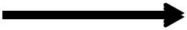 5

The sign of p_{k},is the same as the sign of d_{l}–d₂, since ∆x>0 for our example. Parameter cis constant and has the value 2∆y + ∆x(2b - l), which is independentof pixel position and will be eliminated in the recursive calculations for p_{k}. If the pixel at y_{k}is closer to the line path than the pixel at y_{k}+1(that is, d_{l}<d₂), then decision parameter p_{k}is negative. In that case, we plot the lower pixel; otherwise, we plot the upper pixel.

Coordinate changes along the line occur in unit steps in either the x or y directions. Therefore, we can obtain the values of successive decision parameters using incremental integer calculations. At step k + 1, the decision parameter is evaluated from Eq. 5as
p_{k+1}=2∆y.x_{k+1}-2∆x.y_{k+1}+c

Subtracting Eq. 5 from the preceding equation, we have
p_{k+1}-p_{k} =2∆y(x_{k+1}-x_{k})-2∆x(y_{k+1}-y_{k})
But x_{k+1}, = x_{k}+ 1, so that
p_{k+1}=p_{k} + 2∆y-2∆x(y_{k+1}-y_{k})

Where the term y_{k+1}- y_{k}is either 0 or 1, depending on the sign of parameter p_{k}.This recursive calculation of decision parameters is performed at each integerx

Dept. of Computer Science And Applications, SJCET, Palai 30

MODULE I | MCA-301 COMPUTER GRAPHICS | ADMN 2011-‘14

position, starting at the left coordinate endpoint of the line. The first parameter, p₀, is evaluated from Eq. 5 at the starting pixel position (x_{o}, y_{o}) and withm evaluated as ∆y/∆x:

We can summarize Bresenham line drawing for a line with a positive slope less than 1 in the following listed steps. The constants 2∆y and 2∆y - 2∆x are calculated once for each line to be scan converted, so the arithmetic involves only integer addition and subtraction of these two constants.

Bresenham's Line-Drawing Algorithm for I mI<1

1. Input the twoline endpoints and store the left endpoint in (x_{o},y_{o})
- Load (x_{O}, y_{O})into the frame buffer; that is, plot the first point.

- Calculate constants ∆x, ∆y, 2∆y, and 2∆y - 2∆x, and obtain the startingvalue for the decision parameter as
p_{o}= 2∆y - ∆x

- At each x_{k}along the line, starting at k = 0, perform the following test: If P_{k}< 0, the next point to plot is (x_{k}+1,y_{k})and
P_{k+1}=P _{k}+2∆y

Otherwise, the next point to plot is (x_{k}+ 1 ,y_{k}+ 1) and p_{k+1}= p_{k}+ 2∆y - 2∆x

- Repeat step 4 ∆x times.

1.5 CIRCLE DRAWING

We know that the equation of a circle centered at the origin is x² + y² = R²,
where (0, 0) is the origin R is the radius and (x, y) is any point on the circle.
x² + y² = R²
y² = R² – x²
y = + √ (R² – x²)
To draw a quarter circle, we can increment x from 0 to R in unit steps, solving for +y at each step.

This method will work, but it is inefficient because of the multiply and square root operations. Here the circle will have large gaps for values of x close to R, because the slope of the circle becomes infinite there.

Eight-way symmetry

We can improve the process of the previous section by taking greater advantage of the symmetry in a circle. Consider first a circle centered at the origin.

That is (0, 0). If the point (x, y) is on the circle the new can trivially compute seven other points on the circle as in Fig: 1.38

Dept. of Computer Science And Applications, SJCET, Palai 31

MODULE I | MCA-301 COMPUTER GRAPHICS | ADMN 2011-‘14
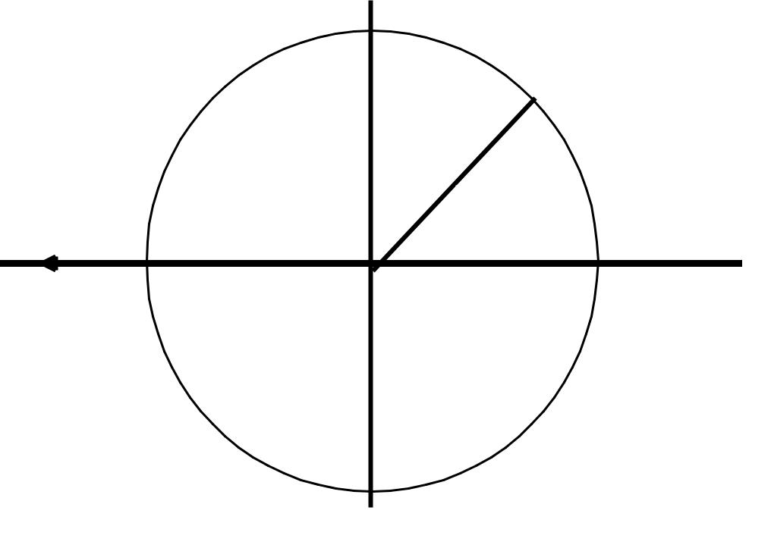

-y,x | y, x

-x, y | x, y
45^{O}

-x, -y | x, -y

-y, -x y,-x

(Fig: 1.38, Eight symmetrical points on a circle)

We need to compute only one 45-degree segment to determine the circle completely. For a circle centered at the origin (0,0), the eight symmetrical points can be displayed with procedure circlepoints().

Void circlepoints (int x, int y)

{

putpixel ( x, y);

putpixel ( y, x);

putpixel ( y, -x);

putpixel ( x, -y);

putpixel ( -x, -y);

putpixel ( -y, -x);

putpixel ( -y, x);

putpixel ( -x, y);

}

This procedure can be easily generalized to the case of circles with arbitrary centers. Suppose the point (xcenter, ycenter) is the center of the circle. Then the above function can be modified as

Void circlepoints(xcenter, ycenter, x, y)

intxcenter, ycenter, x, y;

{

putpixel ( xcenter + x, ycenter + y);

putpixel ( xcenter + y, ycenter + x);

putpixel ( xcenter + y, ycenter - x);

Dept. of Computer Science And Applications, SJCET, Palai 32

MODULE I | MCA-301 COMPUTER GRAPHICS | ADMN 2011-‘14

putpixel ( xcenter + x, ycenter - y);

putpixel ( xcenter - x, ycenter - y);

putpixel ( xcenter - y, ycenter - x);

putpixel ( xcenter -y, ycenter + x);

putpixel ( xcenter - x, ycenter + y);

}

1.5.1 DDA ALGORITHM

To write an algorithm to generate a circle of the form (x-a)²+(y-b)²=r² by the help of digital differential analyzer where (a,b) is the center of the circle and r is the radius.

- START

2. Get the values of the center (a,b) and radius (r) of the circle.

3. Find the polar co-ordinates by

x=a+rcosθ

y=b+rsinθ

4. Plot the points(x,y) corresponding to the values of θ ,where θ lies between 0 and

360.

5.STOP

1.5.2 MIDPOINT CIRCLE ALGORITHM (Bresenham's Circle Algorithm)

As in the raster line algorithm, we sample at unit intervals and determine the closest pixel position to the specified circle path at each step. For a given radius r and screen center position (x_{c} ,y_{c}), we can first set up our algorithm to calculatepixel positions around a circle path centered at the coordinate origin (0,0).Then each calculated position (x, y) is moved to its proper screen position by adding x_{c}to x and y_{c}toy. Along the circle section from x = 0 to x = y in the first quadrant, the slope of the curve varies from 0 to -1. Therefore, we can take unit steps in the positive x direction over this octant and use a decision parameter to determine which of the two possible y positions is closer to the circle path at each step. Positions in the other seven octants are then obtained by symmetry.

To apply the midpoint method, we define a circle function:
f_{circle}(x,y)=x²+y²-r²

Any point (x,y) on the boundary of the circle with radius r satisfies the equation f_{circle}(x,y)= 0. If the point is in the interior of the circle, the circle function is negative. And if the point is outside the circle, the circle function is positive. To summarize, the relative position of any point (x. y) can be determined by checking the sign of the circle function:

Dept. of Computer Science And Applications, SJCET, Palai 33

MODULE I | MCA-301 COMPUTER GRAPHICS | ADMN 2011-‘14

<0 if(x,y) is inside the circle boundary f_{circle}(x,y) =0 if(x,y) is on the circle boundary

>0if(x,y) is outside the circle boundary

The circle-function tests are performed for the midpositions between pixels near the circle path at each sampling step. Thus, the circle function is the decision parameter in the midpoint algorithm, and we can set up incremental calculations for this function as we did in the line algorithm.

x²+y²-r²=0
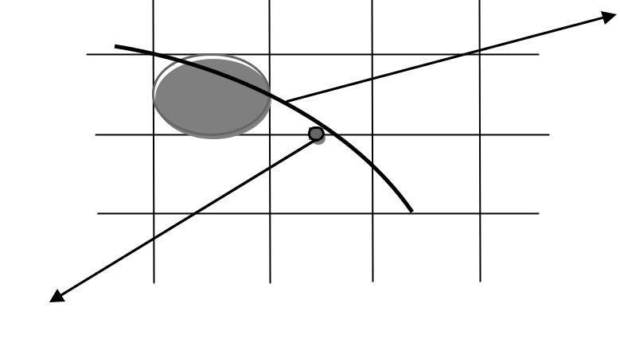

y_{k}

y_{k}- 1

x_{k} | x_{k}+ 1 | x_{k}+2
Midpoint

(Fig: 1.39, Midpoint between candidate pixels at sampling position x_{k}+1 along a

circular path)

Fig:1.39 shows the midpoint between the two candidate pixels at sampling position x_{k}+ 1. Assuming we have just plotted the pixel at (x_{k}, y_{k}), we next need to determine whether the pixel at position (x_{k}+ 1, y_{k}) or the one at position(x_{k}+ 1, y_{k}-1) is closer to the circle. Our decision parameter is the circle function 3-27 evaluated at the midpoint between these two pixels:
p_{k} = f_{circle}(x_{k}+1,y_{k}-(1/2) )
= (x_{k}+1)²+(y_{k}-(1/2))²-r²

If p_{k}<0, this midpoint is inside the circle and the pixel on scan line y_{k}is closer to the circle boundary. Otherwise, the midposition is outside or on the circle boundary, and we select the pixel on scan liney_{k}- 1.

Successive decision parameters are obtained using incremental calculations. We obtain a recursive expression for the next decision parameter by evaluating the circle function at sampling position x_{k+1}+1 = x_{k}+ 2:
p_{k+1} = f_{circle}(x_{k+1}+1,y_{k+1}-(1/2) )

= [(x_{k}+1)+1]²+(y_{k+1}-(1/2))²-r²

Or
p_{k+1}=p_{k}+2(x_{k}+1)+(y²_{k+1}-y²_{k})-(y_{k+1}-y_{k})+1

Dept. of Computer Science And Applications, SJCET, Palai 34

MODULE I | MCA-301 COMPUTER GRAPHICS | ADMN 2011-‘14

Wherey_{k+1}, is either y_{k}or y_{k-1}, depending on the sign of p_{k}. increments for obtaining p_{k+1}, are either 2x_{k+1}+1(if p_{k}is negative) or 2x_{k+1}+1-2y_{k+1}. Evaluation of the terms 2x_{k+1},n d 2y_{k+1},can also be done incrementallyas
2x_{k+1=}2x_{k} +2
2y_{k+1=}2y_{k} -2

At the start position (0, r), these two terms have the values 0 and 2r, respectively. Each successive value is obtained by adding 2 to the previous value of 2xand subtracting 2 from the previous value of 2y.

The initial decision parameter is obtained by evaluating the circle function at the start position (x₀, y₀) = (0, r):
p₀=f_{circle}(1,r-(1/2) )
=1+(r-(1/2))²-r²

Or
p₀=(5/4)-r
If the radius r is specified as an integer, we can simply round p₀to
p₀ = 1 - r(for r an integer) , since all increments are integers.

Asin Bresenham's line algorithm, the midpoint method calculates pixel positions along the circumference of a circle using integer additions and subtractions, assuming that the circle parameters are specified in integer screen coordinate.

We can summarize the steps in the midpoint circle algorithm as follows.

Midpoint Circle Algorithm

- Input radius r and circle center (x_{c},y_{c}), and obtain the first point onthe

circumference of a circle centered on the origin as
(x₀,y₀)=(0,r)

- Calculate the initial value of the decision parameter as
p₀=(5/4)-r
- At each x_{k} position, starting at k = 0, perform the following test: If p_{k}<0, the next point along the circle centered on (0,0) is (x_{k+1}, y_{k}) and
p_{k+1}=p_{k}+2(x_{k+1})+1
Otherwise, the next point along the circle is (x_{k} + 1, y_{k} - 1)and
p_{k+1}=p_{k}+2(x_{k+1})+1-2(y_{k+1})
Where2x_{k+1}, = 2x_{k} + 2and 2y_{k+1}, = 2y_{k} - 2.

4. Determine symmetry points in the other seven octants.
- Move each calculated pixel position (x, y) onto the circular path centered on(x_{c},y_{c})

and plot the coordinate values: x=x+x_{c}, y=y+y_{c}

- Repeat steps 3 through 5 until x ≥y.

Dept. of Computer Science And Applications, SJCET, Palai 35

MODULE I | MCA-301 COMPUTER GRAPHICS | ADMN 2011-‘14

Example:

Given a circle radius r = 10, we demonstrate the midpoint circle algorithm bydetermining positions along the circle octant in the first quadrant hum x = 0 to x =

- The initial value of the decision parameter is
p₀=1-r=-9
For the circle centered on the coordinate origin, the initial point is (x₀,y₀) =(0,

l0), and initial increment terms for calculating the decision parameters are:
2x₀=0,2y₀=20

Successive decision parameter values and positions along the circle path are calculated using the midpoint method as

K | pk | (xk+1,yk+1) | 2xk+1 | 2yk+1
0 | -9 | (1,10) | 2 | 20
1 | -6 | (2,10) | 4 | 20
2 | -1 | (3,10) | 6 | 20
3 | 6 | (4,9) | 8 | 18
4 | -3 | (5,9) | 10 | 18
5 | 8 | (6,8) | 12 | 16
6 | 5 | (7,7) | 14 | 14

1.6. DDA ALGORITHM

To write an algorithm to generate an ellipse using the Digital Differential AnalyzerAlgorithm ( DDA).

Equation to the ellipse is
((x-xc)/r_{x})²+((y-yc)/r_{y})²=1

where (xc,yc) - center of the ellipse.
r_{x}- x radius of ellipse, r_{y}-y radius of ellipse.

- START

- Get the centre (xc,yc),x radius (rx) and y radius (ry) of the ellipse.

- The polar co-ordinates on an ellipse are

x=xc+rxcosθ

y=yc+r y sinθ

- Plot the point(x,y) corresponding to the values of θ where 0<=θ<=360

- STOP

1.7 PARALLEL LINE ALGORITHMS

With a parallel computer, we can calculate pixel positions along a line path simultaneously by partitioning the computations among the various processors

Dept. of Computer Science And Applications, SJCET, Palai 36

MODULE I | MCA-301 COMPUTER GRAPHICS | ADMN 2011-‘14

available. One approach to the partitioning problem is to adapt an existing sequential algorithm to take advantage of multiple processors. Alternatively, we can look for other ways to set up the processing so that pixel positions can be calculated efficiently in parallel. An important consideration in devising a parallel algorithm is to balance the processing load among the available processors.

Given n_{p} processors, we can set up a parallel Bresenham line algorithm by subdividing the line path into n_{p} partitions and simultaneously generating line segments in each of the subintervals. For a line with slope 0 < m < 1 and left endpoint coordinate position (x0, y0), we partition the line along the positive x direction. The distance between beginning x positions of adjacent partitions can be calculated as

∆x_{p}=(∆x+n_{p}-1)/n_{p}

where ∆x is the width of the line, and the value for partition width ∆x_{p} is computed using integer division. Numbering the partitions, and the processors, as 0,1,2, up to n, - 1, we calculate the starting x coordinate for the kth partition as

x_{k}=x0+k∆x_{p}

As an example, suppose ∆x=15 and we have n_{p}=4 processors. Then the width of the partitions is 4 and the starting x values for the partitions are x0, x0 + 4, x0 +8, and x0 + 12. With this partitioning scheme, the width of the last (rightmost) subinterval will be smaller than the others in some cases. In addition, if the line endpoints are not integers, truncation errors can result in variable width partitions along the length of the line.

To apply Bresenham's algorithm over the partitions, we need the initial value for the y coordinate and the initial value for the decision parameter in each partition. The change ∆y_{p}, in the y direction over each partition is calculated from the line slope

- and partition width ∆x_{p}: ∆y_{p}= m∆x_{p}

At the kth partition, the starting y coordinate is then

y_{k}=y0+round(k∆y_{p})

The initial decision parameter for Bresenham’s algorithm at the start of the kth subinterval is obtained from

p_{k}=(k∆x_{p})(2∆y)-round(k∆y_{p})(2∆x)+2∆y-∆x

Each processor then calculates pixel positions over its assigned subinterval using the starting decision parameter value for that subinterval and the starting coordinates (x0,y0).We can also reduce the floating-point calculations to integer arithmetic in the computations for starting values y_{k} and p_{k} by substituting m =∆y/∆x and rearranging terms. The extension of the parallel Bresenham algorithm to a line with slope greater than 1 is achieved by partitioning the line in the y direction and

Dept. of Computer Science And Applications, SJCET, Palai 37

MODULE I | MCA-301 COMPUTER GRAPHICS | ADMN 2011-‘14

calculating beginning x values for the partitions. For negative slopes, we increment coordinate values in one direction and decrement in the other.

y₂
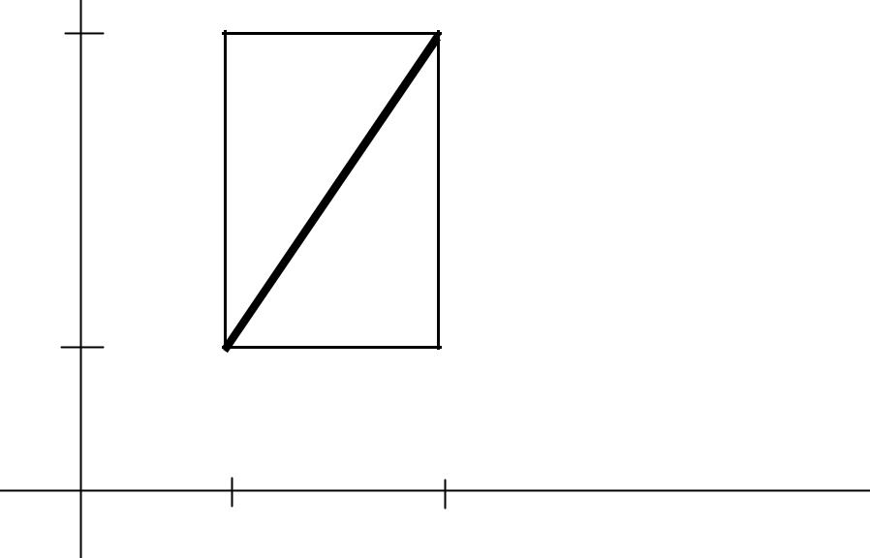

∆y

y1

∆x

x1 x₂

(Fig: 1:44 Bounding box for a line with coordinate extents ∆x and ∆y)

Dept. of Computer Science And Applications, SJCET, Palai 38

